**DUE TO THE FOLLOWING ERROR MESSAGE I CANNOT SAVE MY FILE**

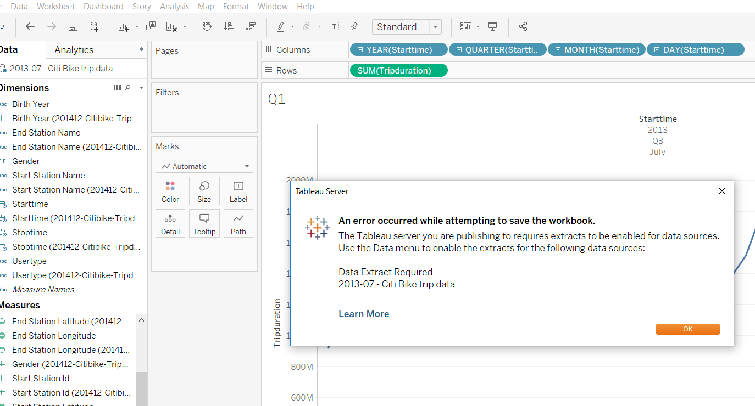

*1 **How many trips have been recorded total during the chosen period?**

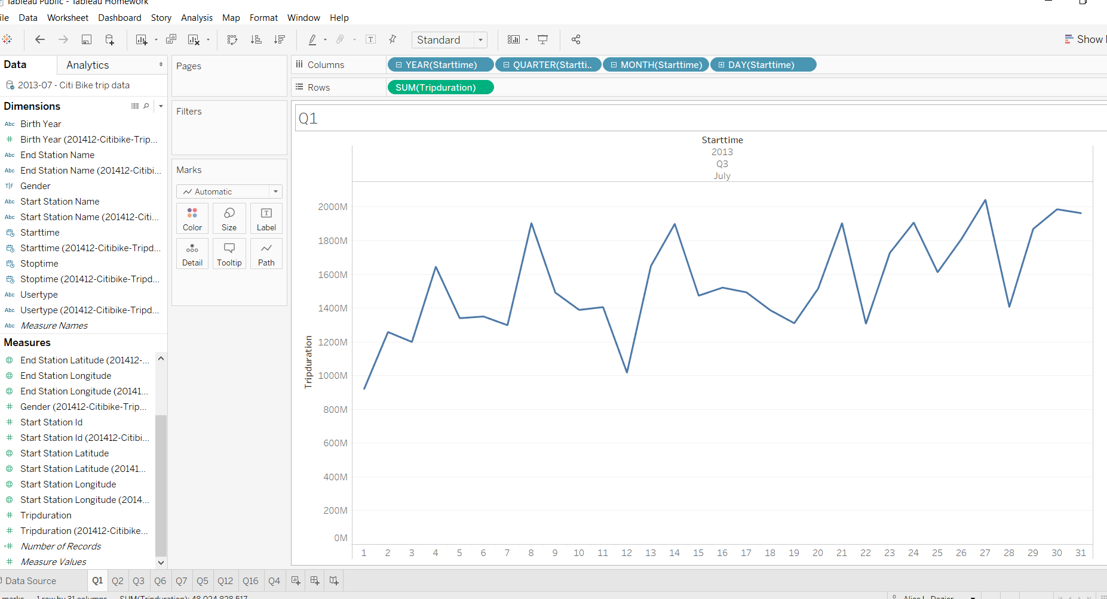

**\* 2 By what percentage has total ridership grown?**

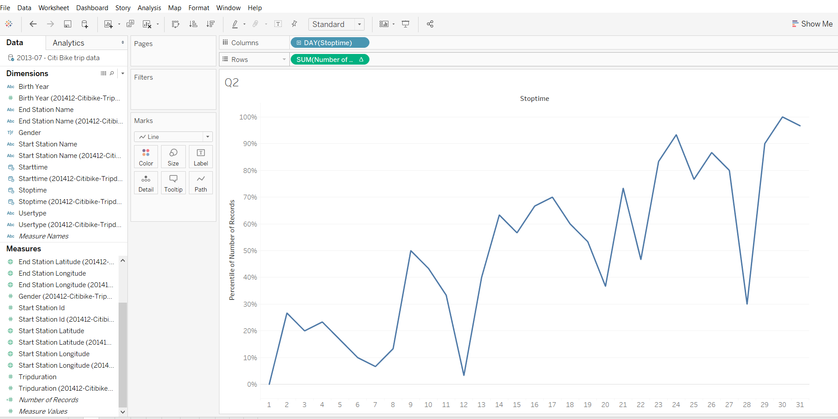

**3. How has the proportion of short-term customers and annual subscribers changed?**

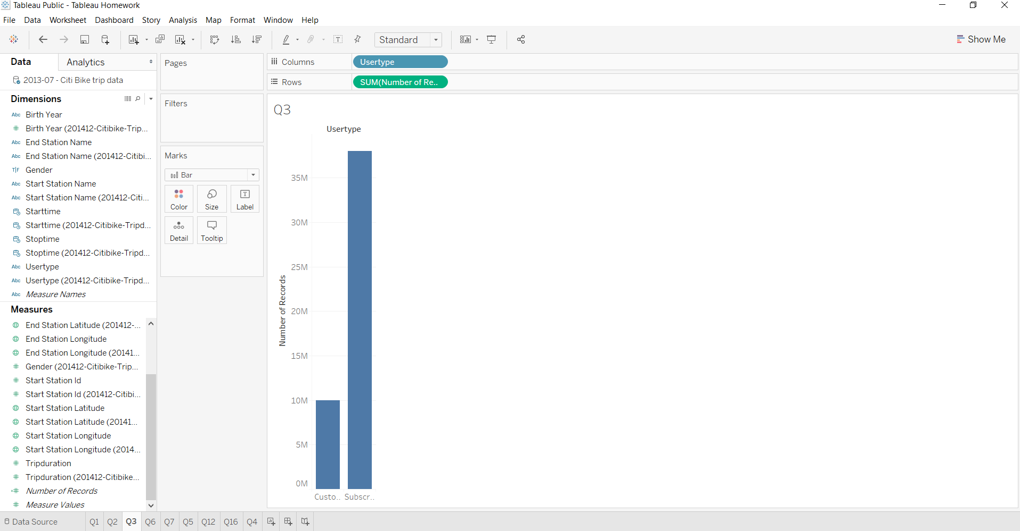

**What are the peak hours in which bikes are used during summer months?**

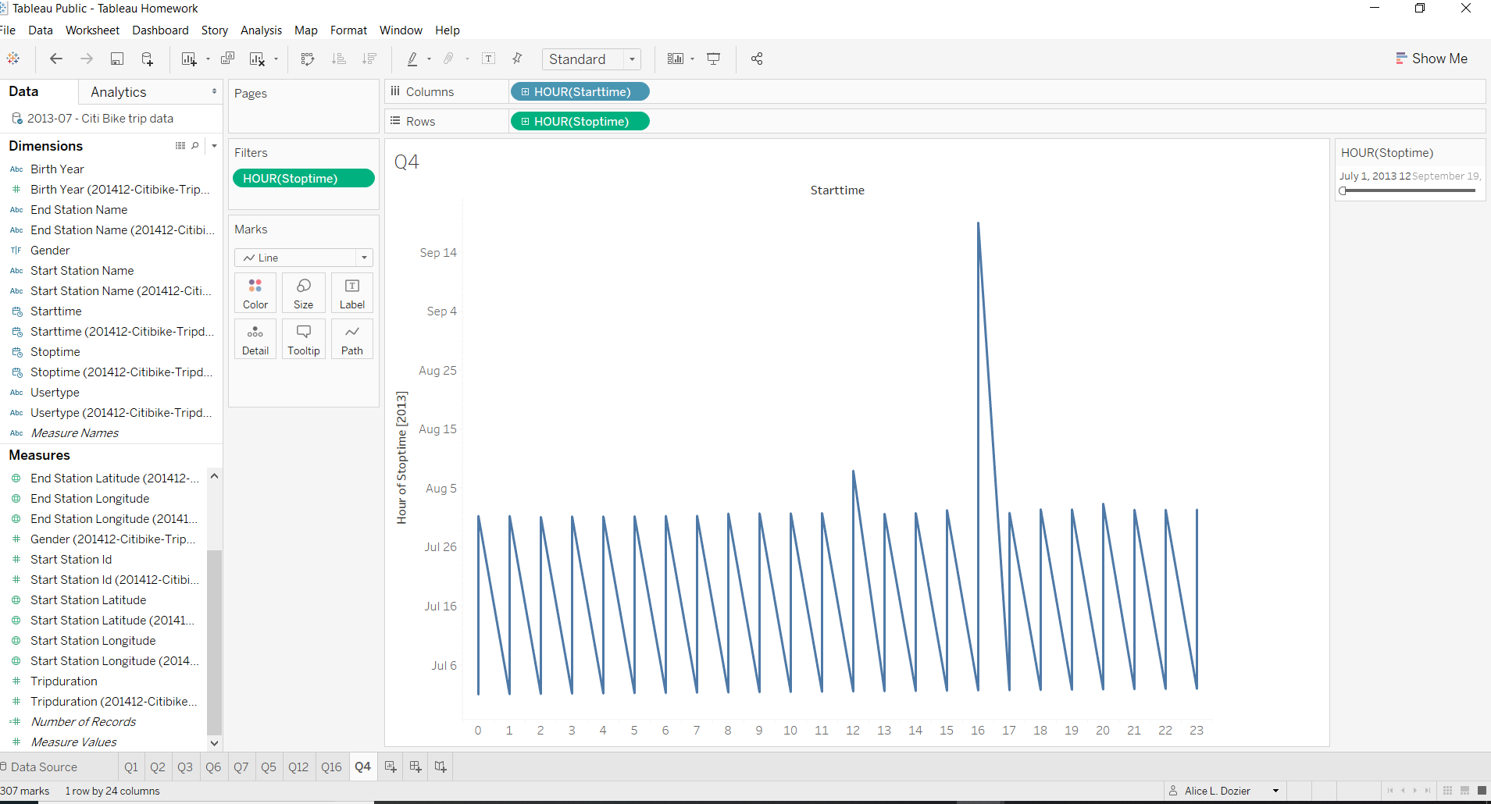

*5 What are the peak hours in which bikes are used during winter months?

* 6 Today, what are the top 10 stations in the city for starting a journey? (Based on data, why do you hypothesize these are the top locations?) Duplicate Question

* 7 **Today, what are the top 10 stations in the city for ending a journey? (Based on data, why?)**

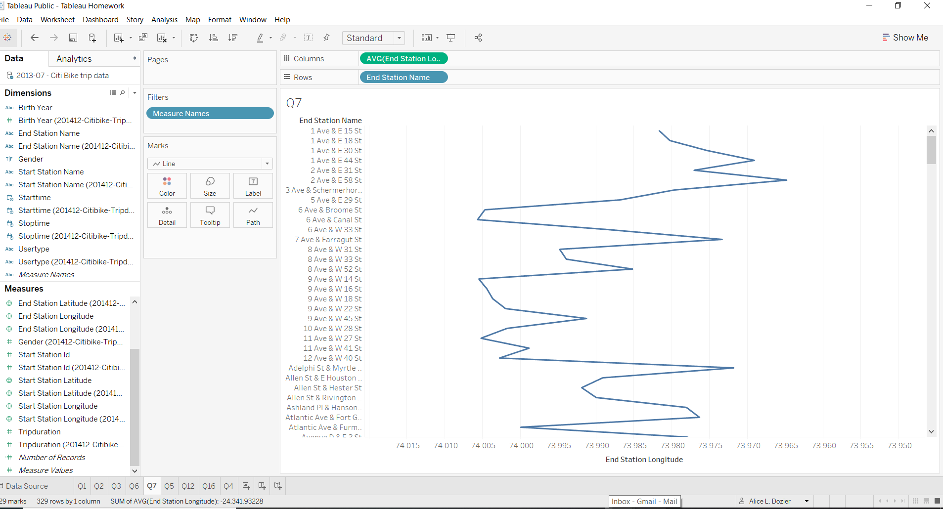

* 7 **Today, what are the top 10 stations in the city for ending a journey? (Based on data, why?)**

*8 **Today, what are the bottom 10 stations in the city for starting a journey? (Based on data, why?)**

* 9 Today, what are the bottom 10 stations in the city for ending a journey (Based on data, why?)/Duplicate Question

* 10 Today, what is the gender breakdown of active participants (Male v. Female)?

* 11 How effective has gender outreach been in increasing female ridership over the timespan?

\***12 How does the average trip duration change by age?**

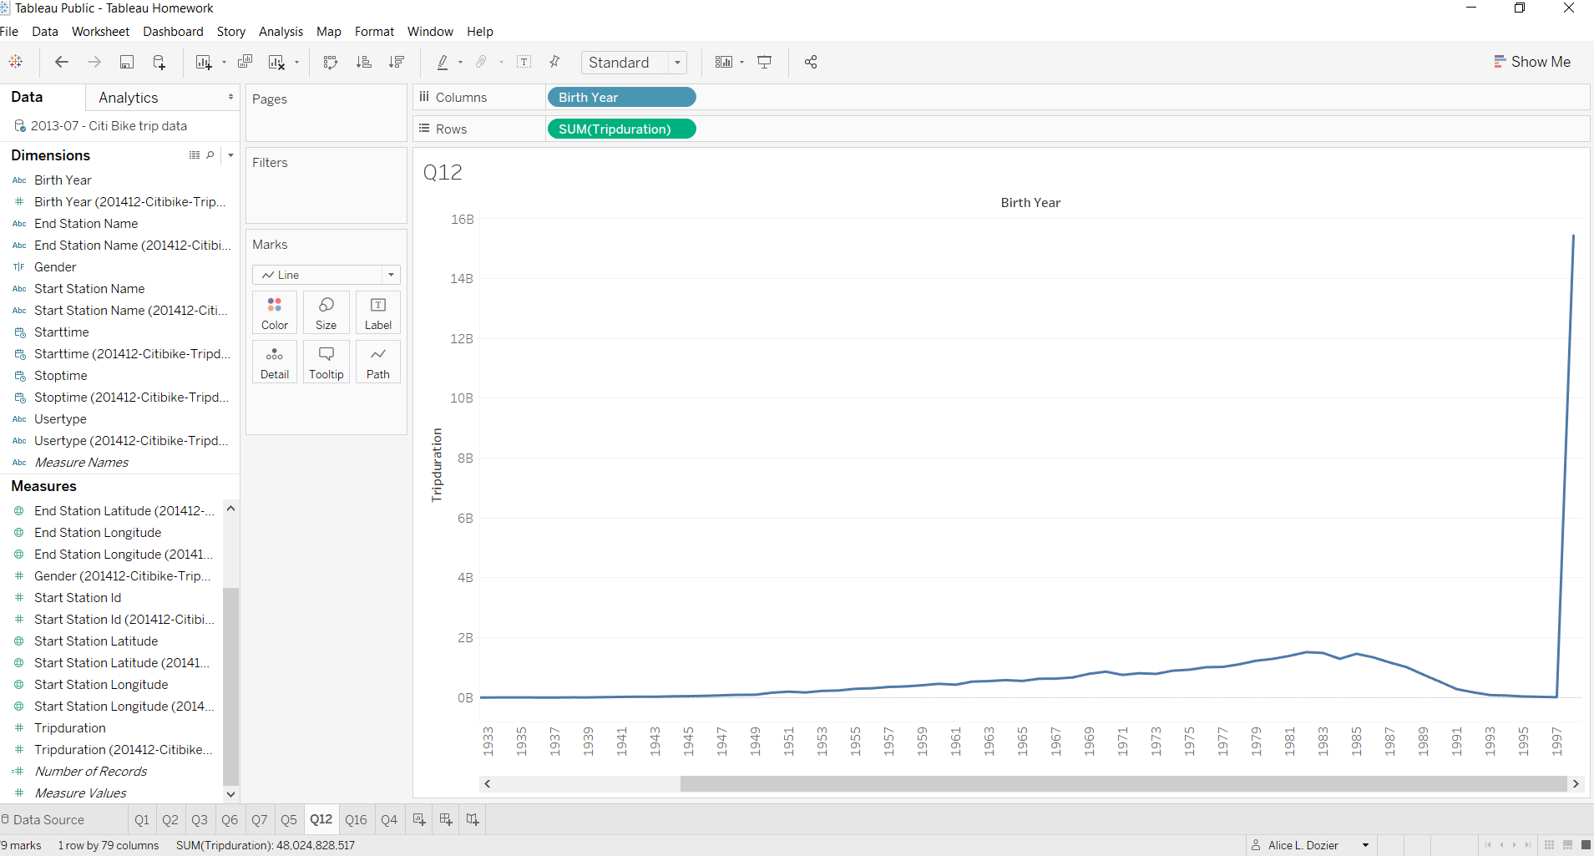

What is the average distance in miles that a bike is ridden?

*14 Which bikes (by ID) are most likely due for repair or inspection in the timespan?

* 15 How variable is the utilization by bike ID?

*16 **A static map that plots all bike stations with a visual indication of the most popular locations to start and end a journey with zip code data overlaid on top.**

